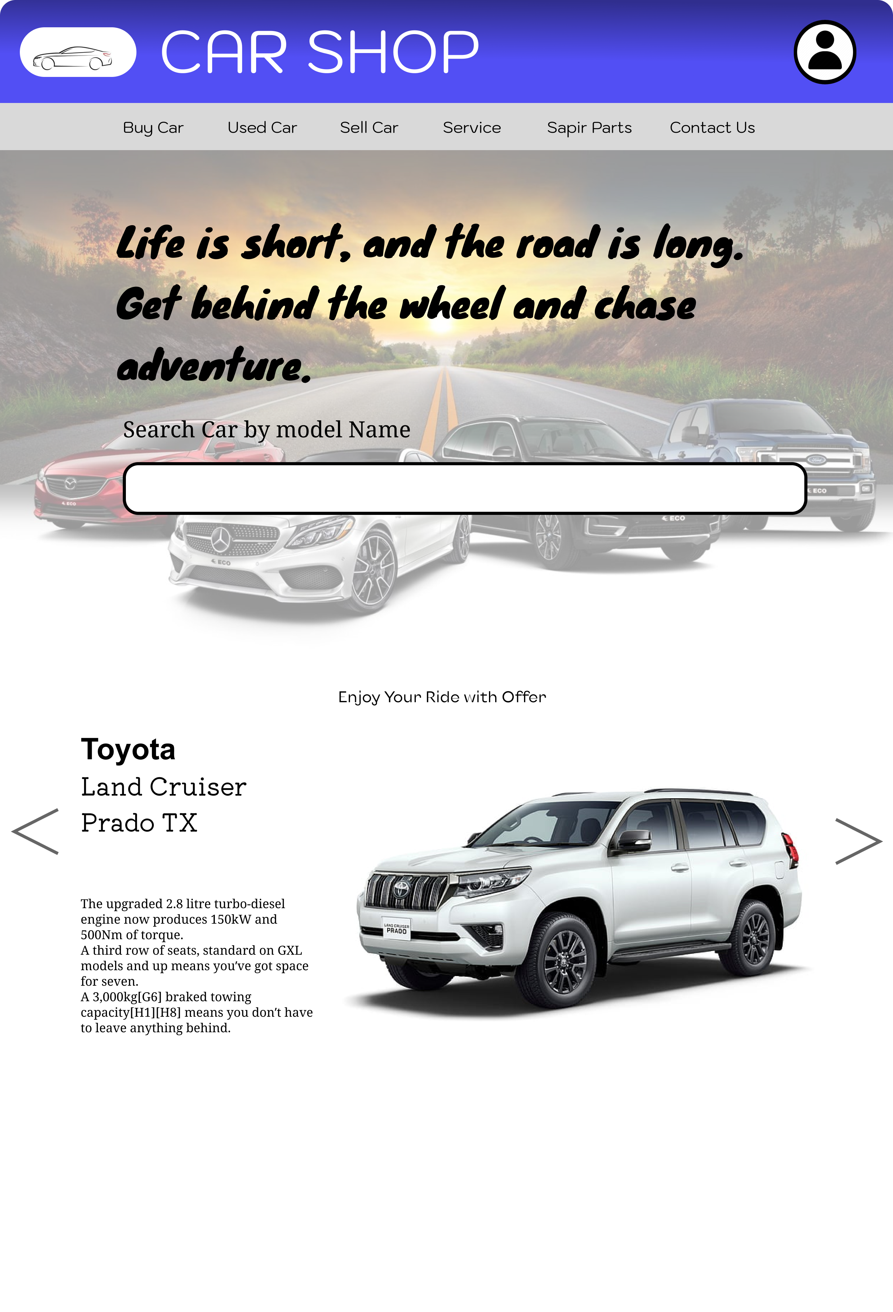

Link: https://www.figma.com/design/EKRlouWmMujucLii2Fg82g/Car_Shop_Manager_Portal?node-id=199-2&t=idPKcVDRiwm15MgZ-1

